**Docker Compose Build**

The folder structure for Docker image will look like the below, this will be used to build through Docker compose

Folder Structure  
  


**Docker build successfully carried out as below:**

docker compose up --build –d

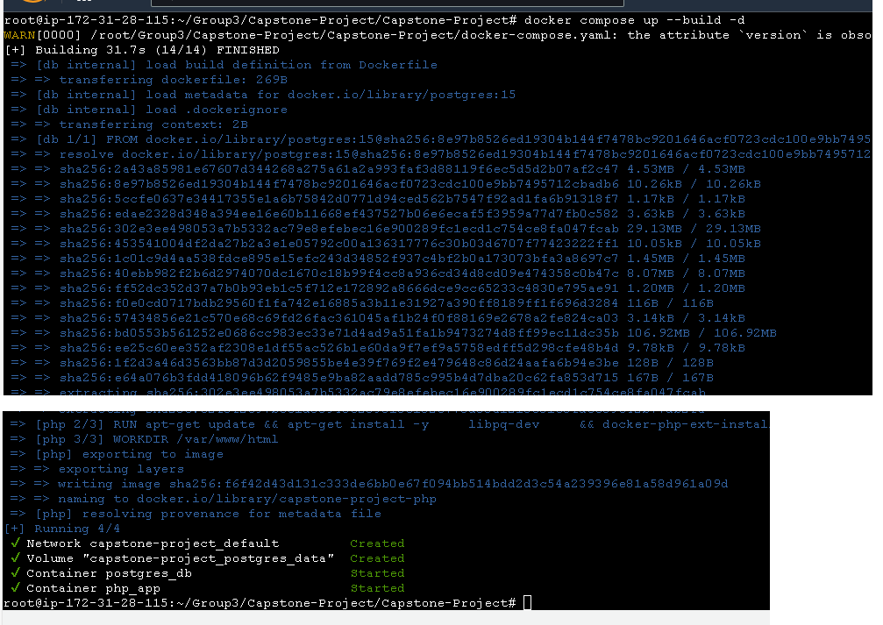

**Access the Application**:

* Open your browser and navigate to http://localhost:8080.
* You should see a list of users from the PostgreSQL database

Tenants have their employee’s inventory and make quick search of the profile



**Additional commands:**docker compose down  
> to stop the application

docker compose up -d  
> run the container in disconnected mode

**Below is the coding for the docker compose:**

Docker Compose File (docker-compose.yaml)

version: '3.8'

services:

php:

build: ./php

container_name: php_app

ports:

- "8081:80"

volumes:

- ./php:/var/www/html

depends_on:

- db

environment:

- DB_HOST=db

- DB_USER=myuser

- DB_PASSWORD=mypassword

- DB_NAME=mydb

db:

build: ./postgres

container_name: postgres_db

environment:

POSTGRES_DB: mydb

POSTGRES_USER: myuser

POSTGRES_PASSWORD: mypassword

ports:

- "5432:5432"

volumes:

- postgres_data:/var/lib/postgresql/data

- ./init.sql:/docker-entrypoint-initdb.d/init.sql

volumes:

postgres_data:

Initialzation SQL File (init.sql)  
This file will initialize the database with a sample table when the PostgreSQL container starts.

-- Create the employees table

CREATE TABLE employees (

employee_id SERIAL PRIMARY KEY, -- Unique ID for each employee

first_name VARCHAR(100), -- Employee's first name

last_name VARCHAR(100), -- Employee's last name

department VARCHAR(100), -- Department where the employee works

job_title VARCHAR(100), -- Employee's job title

email VARCHAR(100), -- Employee's email address

phone_number VARCHAR(15), -- Employee's contact number

hire_date DATE, -- Date the employee was hired

status VARCHAR(20) -- Current employment status

);

-- Insert 10 sample employees

INSERT INTO employees (first_name, last_name, department, job_title, email, phone_number, hire_date, status) VALUES

('John', 'Doe', 'Sales', 'Sales Manager', 'john.doe@example.com', '(555) 123-4567', '2020-01-15', 'Active'),

('Jane', 'Smith', 'Marketing', 'Marketing Specialist', 'jane.smith@example.com', '(555) 234-5678', '2021-03-20', 'Active'),

('Alice', 'Johnson', 'IT', 'Software Engineer', 'alice.johnson@example.com', '(555) 345-6789', '2019-07-11', 'Inactive'),

('Bob', 'Brown', 'HR', 'HR Manager', 'bob.brown@example.com', '(555) 456-7890', '2018-11-05', 'Active'),

('Charlie', 'Davis', 'Finance', 'Accountant', 'charlie.davis@example.com', '(555) 567-8901', '2022-02-14', 'Active'),

('Diana', 'Moore', 'Sales', 'Sales Associate', 'diana.moore@example.com', '(555) 678-9012', '2023-05-01', 'Active'),

('Ethan', 'Clark', 'Marketing', 'SEO Specialist', 'ethan.clark@example.com', '(555) 789-0123', '2023-06-10', 'Active'),

('Fiona', 'Adams', 'IT', 'Systems Analyst', 'fiona.adams@example.com', '(555) 890-1234', '2022-09-15', 'Active'),

('George', 'Wright', 'Finance', 'Financial Analyst', 'george.wright@example.com', '(555) 901-2345', '2020-04-22', 'Inactive'),

('Hannah', 'Baker', 'HR', 'Recruiter', 'hannah.baker@example.com', '(555) 012-3456', '2021-08-30', 'Active');

PHP Docker file (Php/dockerfile)

# Use official PHP Apache image

FROM php:8.1-apache

# Install PostgreSQL client libraries and required extensions

RUN apt-get update && apt-get install -y \

libpq-dev \

&& docker-php-ext-install pdo pdo_pgsql pgsql \

&& apt-get clean && rm -rf /var/lib/apt/lists/*

# Set working directory

WORKDIR /var/www/html

# Expose port 80

EXPOSE 80

# Start Apache server

CMD ["apache2-foreground"]

PHP Application (Php/index.php file)  
Here is a simple PHP script that connects to PostgreSQL and fetches data from the users table.

<!DOCTYPE html>

<html lang="en">

<head>

<meta charset="UTF-8">

<meta name="viewport" content="width=device-width, initial-scale=1.0">

<title>Employees List</title>

<style>

body {

font-family: Arial, sans-serif;

margin: 20px;

padding: 0;

background-color: #f4f4f4;

}

h1 {

color: #333;

}

table {

width: 100%;

border-collapse: collapse;

margin: 20px 0;

}

table, th, td {

border: 1px solid #ddd;

}

th, td {

padding: 12px;

text-align: left;

}

th {

background-color: #f2f2f2;

}

input[type="text"] {

padding: 8px;

width: 300px;

margin: 10px 0;

}

</style>

<script>

// Search Functionality

function searchUsers() {

var input, filter, table, tr, td, i, txtValue;

input = document.getElementById("searchInput");

filter = input.value.toUpperCase();

table = document.getElementById("employeesTable");

tr = table.getElementsByTagName("tr");

for (i = 1; i < tr.length; i++) {

tr[i].style.display = "none";

td = tr[i].getElementsByTagName("td");

for (var j = 0; j < td.length; j++) {

if (td[j]) {

txtValue = td[j].textContent || td[j].innerText;

if (txtValue.toUpperCase().indexOf(filter) > -1) {

tr[i].style.display = "";

break;

}

}

}

}

}

</script>

</head>

<body>

<h1>Employees List</h1>

<!-- Search Box -->

<input type="text" id="searchInput" onkeyup="searchUsers()" placeholder="Search for names or emails..">

<?php

// Connection details

$host = getenv('DB_HOST');

$dbname = getenv('DB_NAME');

$user = getenv('DB_USER');

$password = getenv('DB_PASSWORD');

$dsn = "pgsql:host=$host;dbname=$dbname";

try {

// Connect to PostgreSQL database

$pdo = new PDO($dsn, $user, $password, [PDO::ATTR_ERRMODE => PDO::ERRMODE_EXCEPTION]);

// Fetch data from the employees table

$stmt = $pdo->query("SELECT * FROM employees");

$employees = $stmt->fetchAll(PDO::FETCH_ASSOC);

// Start of table

echo "<table id='employeesTable'>";

echo "<tr><th>ID</th><th>First Name</th><th>Last Name</th><th>Department</th><th>Job Title</th><th>Email</th><th>Phone</th><th>Hire Date</th><th>Status</th></tr>";

// Display the employees in the table

foreach ($employees as $employee) {

echo "<tr>

<td>{$employee['employee_id']}</td>

<td>{$employee['first_name']}</td>

<td>{$employee['last_name']}</td>

<td>{$employee['department']}</td>

<td>{$employee['job_title']}</td>

<td>{$employee['email']}</td>

<td>{$employee['phone_number']}</td>

<td>{$employee['hire_date']}</td>

<td>{$employee['status']}</td>

</tr>";

}

echo "</table>";

} catch (PDOException $e) {

echo "Error: " . $e->getMessage();

}

?>

</body>

</html>

PostgreSQL Dockerfile (Postgres/Dockerfile)

# Use official PostgreSQL image

FROM postgres:15

# Set environment variables for database initialization

ENV POSTGRES_DB=mydb

ENV POSTGRES_USER=myuser

ENV POSTGRES_PASSWORD=mypassword

# Expose PostgreSQL default port

EXPOSE 5432